A **stored procedure** is a precompiled set of one or more SQL statements that are stored on SQL Server. The benefit of Stored Procedures is that they are executed on the server-side and perform a set of actions, before returning the results to the client-side. This allows a set of actions to be executed with minimum time and also reduces the network traffic. Hence stored procedure improves performance to execute SQL statements.

Types of Stored Procedure

1. System Defined Stored Procedure

These stored procedures are already defined in[SQL Server](https://www.dotnettricks.com/learn/sqlserver). These are physically stored in hidden SQL Server Resource Database and logically appear in the sys schema of each user-defined and system-defined database. This procedure starts with the sp_ prefix. Hence we don't use this prefix when naming user-defined procedures. Here is a list of some useful system defined procedure.

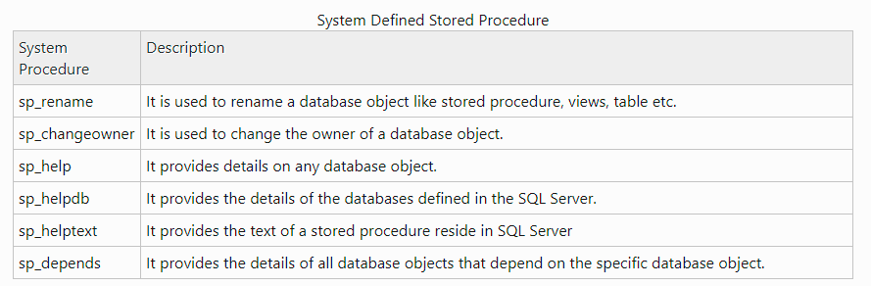

## Extended Procedure

Extended procedures provide an interface to external programs for various maintenance activities. These extended procedures start with the xp_ prefix and stored in the Master database. Basically, these are used to call programs that reside on the server automatically from a stored procedure or a trigger run by the server.

**Why we need extended stored procedure?**

**Extended stored procedures** run in the **SQL Server** process space and are meant to extend the functionality of the database to the host **server**. One **extended stored procedure** useful to the penetration tester is xp_cmdshell, which allows the user to execute commands in a shell on the Windows operating system.

1. User-Defined Stored Procedure

These procedures are created by the user for own actions. These can be created in all system databases except the Resource database or in a user-defined database.

## CLR Stored Procedure

CLR stored procedure is a special type of procedure that is based on the CLR (Common Language Runtime) in [.net framework](https://www.dotnettricks.com/learn/netframework). CLR integration of procedure was introduced with **SQL Server 2008** and allow for the procedure to be coded in one of .NET languages like [C#](https://www.dotnettricks.com/learn/csharp), Visual Basic and F#. I will discuss the CLR stored procedure later.